2/1/2023

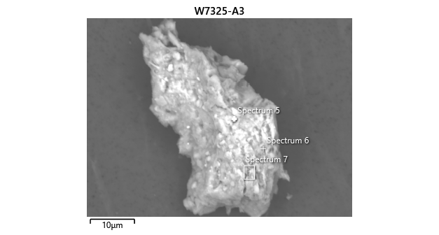

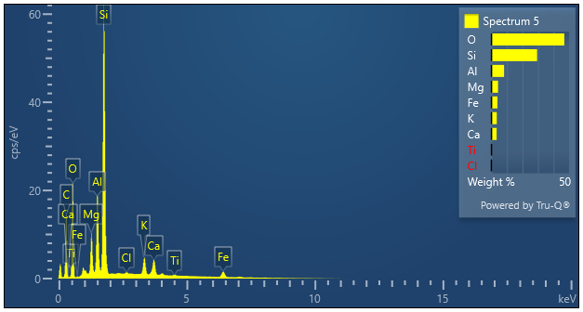

|  |  |  |
| --- | --- | --- |
| **Spectrum 5** |  |  |
| Element | Wt% | Wt% Sigma |
| O | 46.95 |  |
| Mg | 4.26 | 0.04 |
| Al | 8.16 | 0.05 |
| Si | 29.43 | 0.08 |
| Cl | 0.23 | 0.03 |
| K | 3.41 | 0.04 |
| Ca | 3.37 | 0.05 |
| Ti | 0.29 | 0.04 |
| Fe | 3.91 | 0.08 |
| Total: | 100.00 |  |