2/1/2023

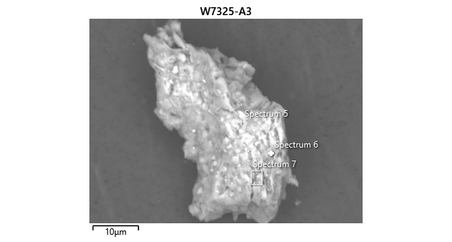

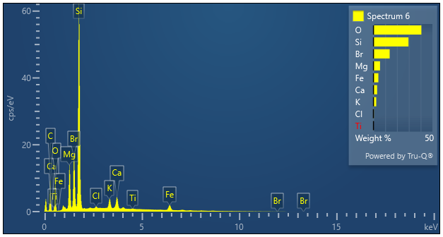

|  |  |  |
| --- | --- | --- |
| **Spectrum 6** |  |  |
| Element | Wt% | Wt% Sigma |
| O | 40.63 |  |
| Mg | 5.62 | 0.04 |
| Si | 29.72 | 0.09 |
| Cl | 0.35 | 0.03 |
| K | 2.37 | 0.04 |
| Ca | 3.14 | 0.04 |
| Ti | 0.18 | 0.04 |
| Fe | 4.22 | 0.08 |
| Br | 13.77 | 0.09 |
| Total: | 100.00 |  |