2/1/2023

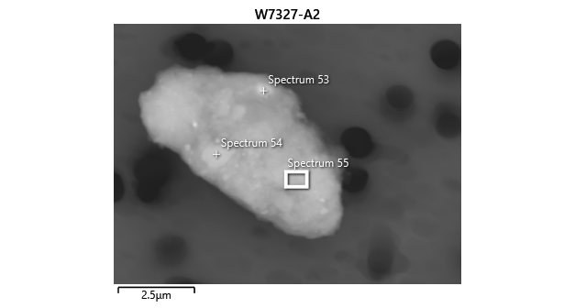

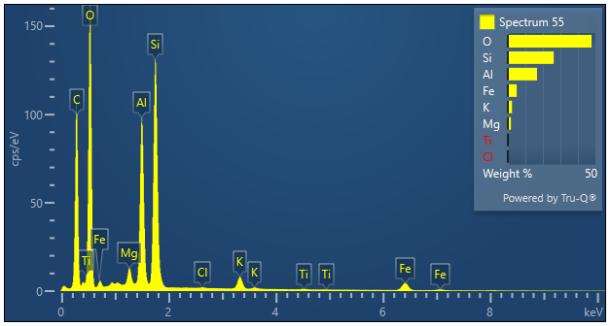

|  |  |  |
| --- | --- | --- |
| **Spectrum 55** |  |  |
| Element | Wt% | Wt% Sigma |
| O | 47.78 |  |
| Mg | 1.75 | 0.02 |
| Al | 16.61 | 0.04 |
| Si | 26.16 | 0.05 |
| Cl | 0.10 | 0.01 |
| K | 2.36 | 0.02 |
| Ti | 0.17 | 0.02 |
| Fe | 5.07 | 0.05 |
| Total: | 100.00 |  |