Stardust Sample C2004, 1, 44, 4, 3
Grid #3 Amorphous C (70 nm thickness)
NOTE: crystalline materials detected by SXRD on this particle

Observations:

A string of ultramicrotome sections is labeled #27 to #36. For no reason at all, I started at #36. The sections #36, #35, #34, #33, #32, #31, #30, #29, #28 and #27 each contain a large piece of aerogel that is mostly massive aerogel (occasionally tiny vesicles) but there many areas of vesicular aerogel (with abundant inclusions; i.e. ‘GEMS’-like) as well as highly vesicular aerogel with geometric vesicles that I interpret as the original aerogel. The latter is not entirely free of tiny inclusions. On the scale of each section the distribution of these differently textured aerogel materials is patchy and random. It appears that massive aerogel contains few and generally smaller inclusions than are present in ‘GEMS’-like aerogel material. This is a qualitative assessment only but see below.

The invariably circular inclusions vary considerably in diameter. There is no correlation between their sizes and the distributions in aerogel. Large and small grains both coexist and isolated. The massive aerogel contains patches of dense concentrations of very tiny inclusions in the aerogel that for this reason cannot yield “clean” aerogel EDS analyses but a combination of inclusions and aerogel matter. In addition, rare (typically large) inclusions can have (1) a hexagonal shape or (2) an irregular shape. The aerogel also contains distinct spheres that are larger (~100 nm and up; see below) than the typical inclusions in “GEMS”-like aerogel

I have analyzed sections #34 and #35 in detail (see below), which means they are ‘compromised” (not destroyed) by exposure to the incident electron beam (at 200keV). I have analyzed only a small fraction of the material in section #33. The other sections, viz. #36 and #32 to #30, were scanned to search for anything that “looked different” but these particular sections look identical to the sections #33, 34 and 35. In sections #29, #28 and #27 I only scanned the aerogel material but concentrated on silicate material.

Sections #33, #34 and #35

I have not spent a lot of time on the “GEMS”-like aerogel. It has been mapped and I will try to obtain a size distribution of these inclusions. In the meantime I concentrated on finding ‘other’ inclusions and comet mineral grains since “crystalline materials detected by SXRD on this particle“. I will provide the details below but up front the crystalline materials detected by HRTEM (EDS+SAED) are:
- Extremely rare pyrrhotite,
- Extremely rare grains that are a regular mixture (crystallographic controlled intergrowth?) of pyrrhotite and kamacite,
- Round kamacite inclusions in the aerogel,
- (Fe,Ni,Cr)₃Si spheres scattered in aerogel, and
- Single crystal forsterite

Table 1
Fe-Ni-S and Fe-Ni (S = 0) inclusions in aerogel sections #33, 34 and35. Most of the inclusions with S = 0 that are alloys are listed separately in this table. Two such grains (anal. #13 and #14 in the upper block of the table could be alloys; their EDS spectrum contains both Si and oxygen (aerogel?) and their elongated shape suggests they could be residual grains of pyrrhotite after complete S-loss. However, I cannot prove this scenario at this time.
Two analyses in section #27 are for the same grain that consists of two differently oriented single-crystals that can both be indexed as pyrrhotite.

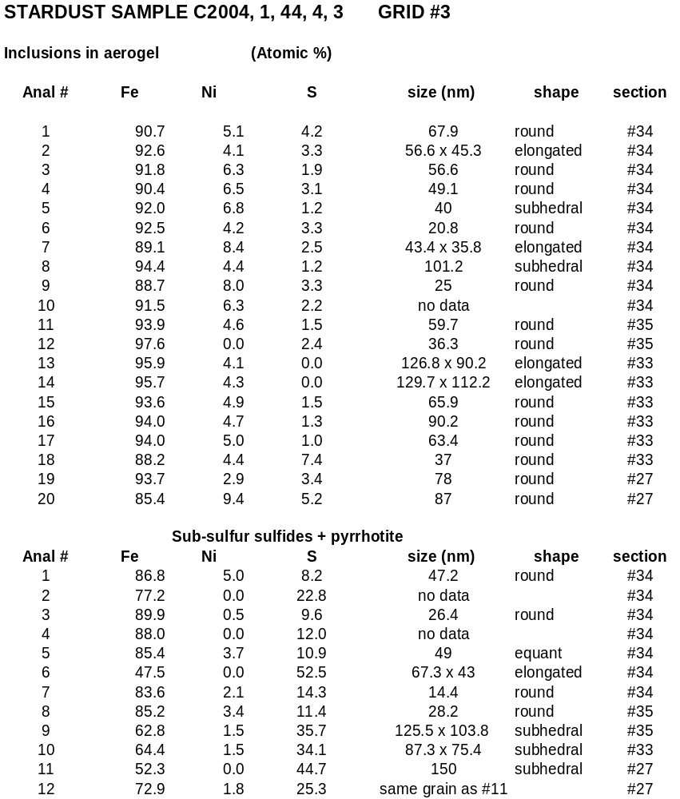
For several of the larger inclusions the sulfur content is plotted as a function of their grain size (Table 1). The result (Figure 1) shows two groups:
- S> 30at% (solid squares), including pyrrhotite (EDS, Table 1). Its SAED pattern indicates that the grain is a single-crystal of pyrrhotite but with evidence for different single-crystal pyrrhotite superlattices, as well as a poorly developed ring pattern that is also a pyrrhotite phase. This ring pattern suggests that a finer grained pyrrhotite is associates with the single-crystal grain. The SAED pattern of a sub-S sulfide (S = 35.7 at%; Table 1) is a superposition of two “shot-gun” patterns that are distinct by the different intensity of their diffraction maxima. Several diffraction maxima, in particular hkl (112), is an alignment of several maxima. The extreme values of the range are consistent with pyrrhotite and kamacite. The diffraction maxima in the “fine-spot” SEAD pattern [0.60, 0.31 and 0.27nm] are consistent with kamacite. The sulfide grains with high S-content, incl. the pyrrhotite crystal, are euhedral grains, and
- S<15at% (open squares), with decreasing S-content the euhedral shape “erodes” to ultimately forming elongated anhedral smooth grains. These grains are distinct from the typically round grains in the “GEMS”-like aerogel.
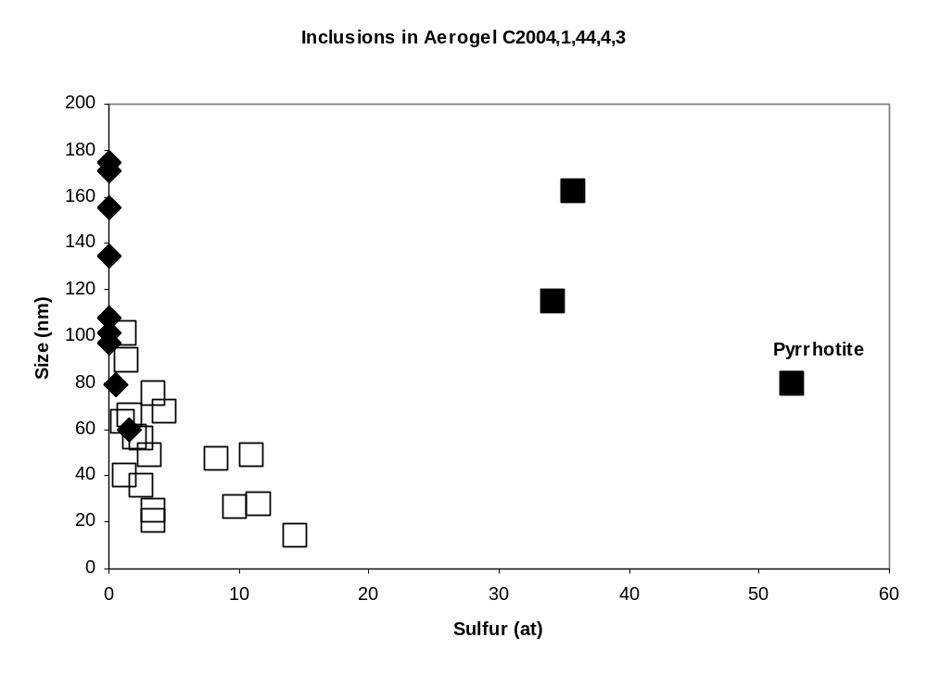
Figure 1: Sulfur content of several ‘large’ inclusions in aerogel inclusions as a function of grain size (nanometer); S> 30at% (solid squares), S<15at% (open squares) and S = 0 (solid diamonds), that are Fe,Si-alloys; see Table 2) .

There is a third group of distinctly large, round inclusions that can be smooth or have a mottled interior texture when transparent. I that case, small inclusions of the type common in “GEMS”-like aerogel can be seen. They are S-free. From 11 such grains, I selected eight ‘very best analyses”, that is, these spheres contain NO oxygen at all. Smaller spheres with zero sulfur may show small O-peaks as well as Si probably contributed by aerogel. The compositions of these eight spheres are listed in Table 2 and are shown in Figure 1 (solid diamonds) along with the sulfides. The alloy compositions are shown in Figure 2 along with the ideal compositions of several Fe,Si alloys

Table 2
Compositions (at%) of alloy spheres and one euhedral alloy grain in aerogel
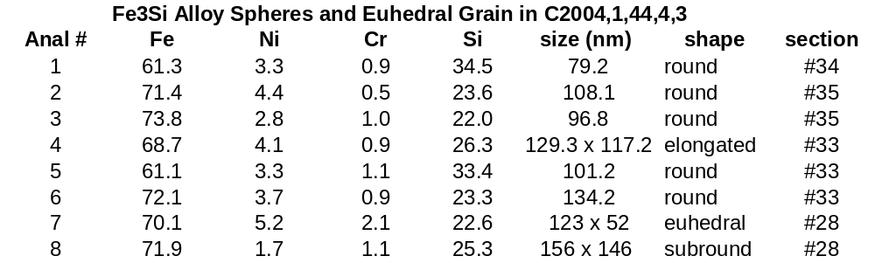

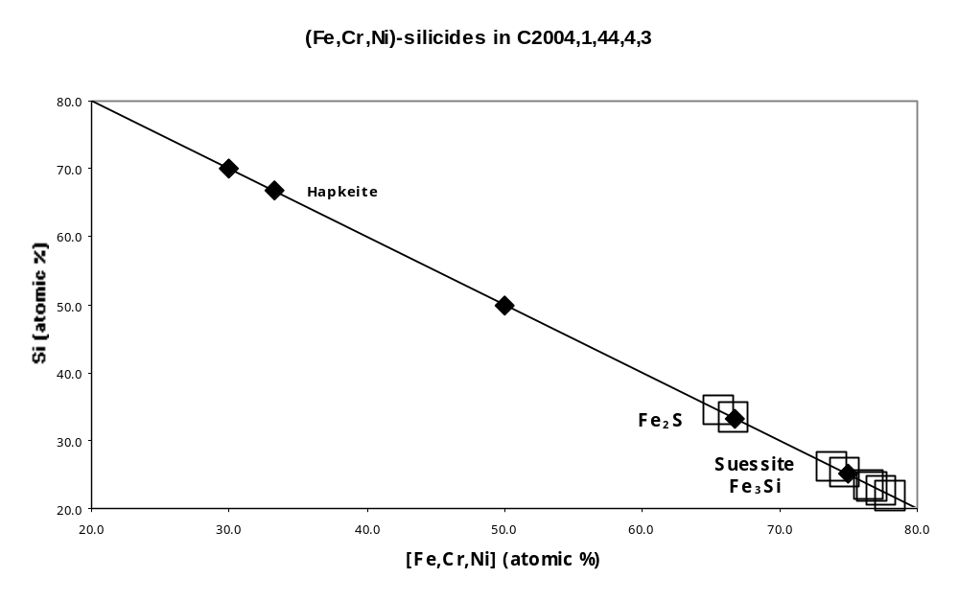

Figure 2: S—Fe (at%) diagram showing various ideal Fe-silicide compositions (solid diamonds) and the compositions of (Fe,Ni,Cr)Si alloys in Stardust aerogel (open squares)

The d-spacings (Å) for these seven spheres and one euhedral grain are consistent with suessite and Fe₃S (Table 3). Along with their composition (Figure 2) they are identified as Fe-rich (Fe,Ni,Cr)Si alloys. It is possible but not likely that all or some fraction of Ni and Cr is contamination from “GEMS”-like inclusion grains. The SAED data show that all these alloy grains are single-crystals. There is clearly a cluster at suessite; Fe₂Si alloy is also present.

Table 3
Interplanar spacings (Å) for the (Fe,Ni,Cr)Si alloys in Stardust aerogel allocation L200C4,1,44,4,3 compared to suessite and Fe₃S (*: data from Keil et al. (1982) Amer. Mineral. 67, 126-131).

Fe,Ni,Cr)Si |  | Suessite* | Fe₃S*
 | 3.19 |  | 3.26 (a₀)
2.83 | 2.95 | 2.84 (a₀) | 2.82
2.00 | 2.05 | 2.01 | 1.99
 |  |  | 1.70
 | 1.47 | 1.42 | 1.41
1.16 |  | 1.16 | 1.15

A weak, single-crystal pattern consisting of distinctly finer maxima than those of the silicide single-crystal pattern is generally superimposed on the latter pattern. On the strength of two diffraction maxima I identify these patterns kamacite, viz. d = 0.31 nm [hkl: 220 (kamacite)] and d = 0.47 nm [hkl: 200 (kamacite)].

Finally, the grains listed in Table 1 contain Chromium ranging between 0.3 at% and 1.5 at%. There is no correlation between Cr-content and the sulfur content and grain size (Figure 3).
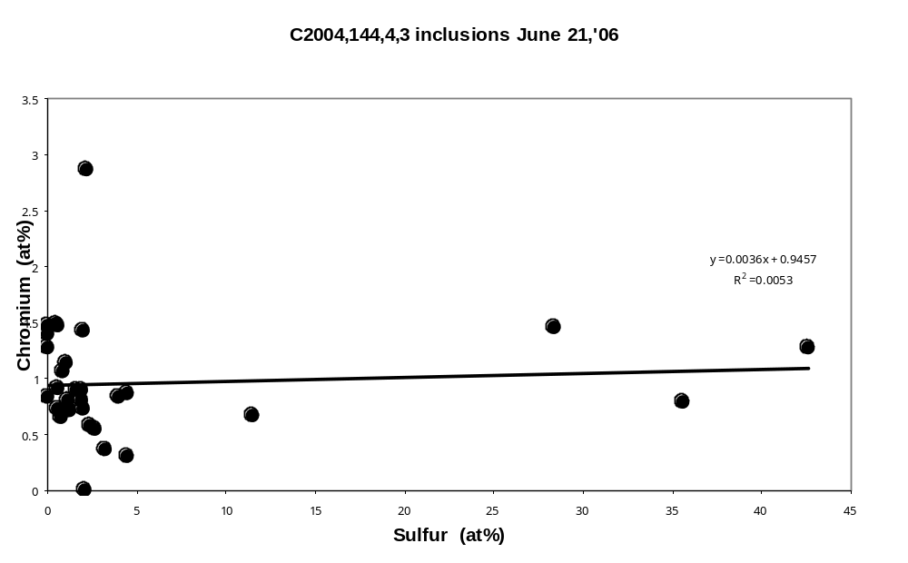
Figure 3: Sulfur vs. Cr (at%) for all inclusions listed in Table 1 measured in the aerogel of allocation C2004,1,44,4,3

Sections #29, #28 and #27

This section is similar to those discussed above but it contains a regularly shaped, single-crystal grain (SEAD) identified as Forsterite. This grain measures 390 x 270 nm in size. Its non-stoichiometric structural formula (see below) is because most of this grain is covered (on top when viewed in the TEM) by aerogel with tiny inclusions.

 | Forsterite
SiO2 | 36.7
MgO | 50.8
FeO | 1.8
 | 99.3
Structural formula
 | O=4
Si | 1.10
Mg | 1.77
Fe | 0.03
 | Fo = 98
 | Fa = 2

This forsterite is partially surrounded by massive zone of silica-rich material with very small opaque inclusions. The S-rich material is amorphous and has a few very small vesicles. There is a sharp boundary between olivine and this massive aerogel zone. This was the first section wherein I detected forsterite that could be the ‘top:’ of a larger single-crystal grain w. The sections #28 and #27 do NOT contain forsterite. I note that section #28 is a very thin with significant loss of sample material. It was probably only a small single-crystal olivine grain.

Sections #28 and #27 contain amorphous material with a shape that suggests they are associated with the amorphous zone around forsterite. These three sections then represent a cross-section through the entire amorphous zone that resulted from interactions between forsterite and aerogel. The compositions in the amorphous rim material are shown in Table 4 for sections #28 and #27.

Table 4
tr: trace amount
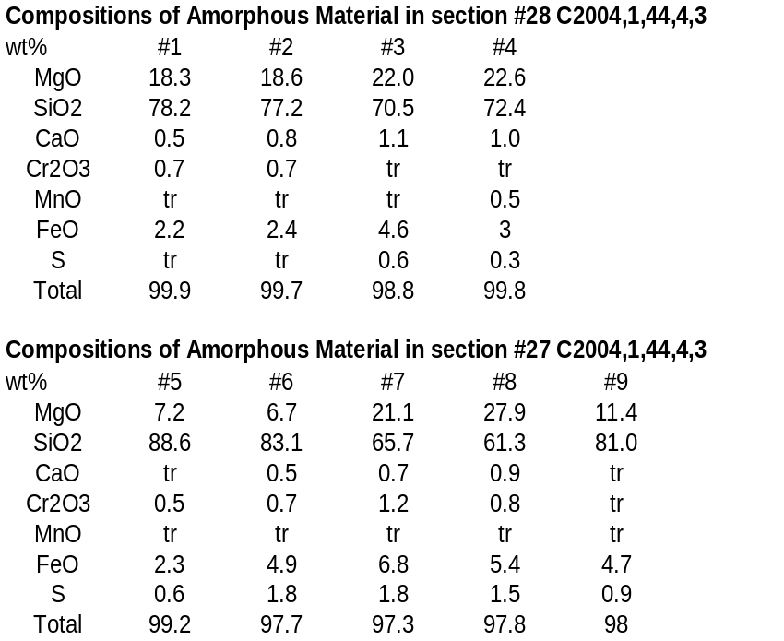

When taken the averages of the analyses shown in Table 4, the continuous chemical changes in the amorphous zone from forsterite to aerogel stand out (Table 5).

Table 5
nd: not detected; tr: trace amount

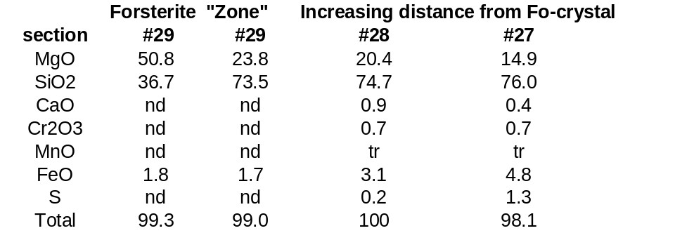

Massive Aerogel Analyses (sections #34 and #35)

The “clean massive aerogel” is stoichiometric SiO₂. It typically has no visible inclusions but “clean” doesn’t mean there are no inclusions smaller than the section thickness along the incident electron beam path. Such small inclusions do exist and can be measured. Aerogel with “scattered inclusions” has slightly larger inclusions. Inclusion clusters do exist. The compositions (Table 6) show that clean aerogel” has a low MgO content. The MgO content is higher in the “aerogel with scattered inclusions” but it is fairly constant (Table 6). The same is true for the Sulfur content, while the FeO contents are variable. It suggests that the inclusions are both (1) metallic Fe, and (2) FeS and Fe,Ni,S (sulfides).

Inclusion sizes (a first approximation; small datasets)
- In “clean aerogel they range from 3-14 nm [(mean ± one stand. dev.): 6 ± 3 nm; number of measurements: 19].
- The “scattered inclusions” range from 3-43.5 nm [(mean ± one stand. dev.): 18 ± 13 nm; number of measurements: 13].

These numbers certainly need to be improved but the main point to take away from these data at this time is that these inclusions are considerably smaller than the grains shown in Figure 1.

Mn and chromium occur in trace amounts are’ not detectable’ but for few exceptions where Cr occurs in <1% concentrations (Table 6).

Table 6
The compositions (oxide wt%), and Mg/(Mg+Fe) (elem.) ratios, for “clean” aerogel (see above) and ‘GEMS’-like aerogel (with scattered inclusions). Also shown is a material I have called “frothy aerogel” because is gives a strong silica signal (see above). [nd: non-detectable, tr: trace amount]

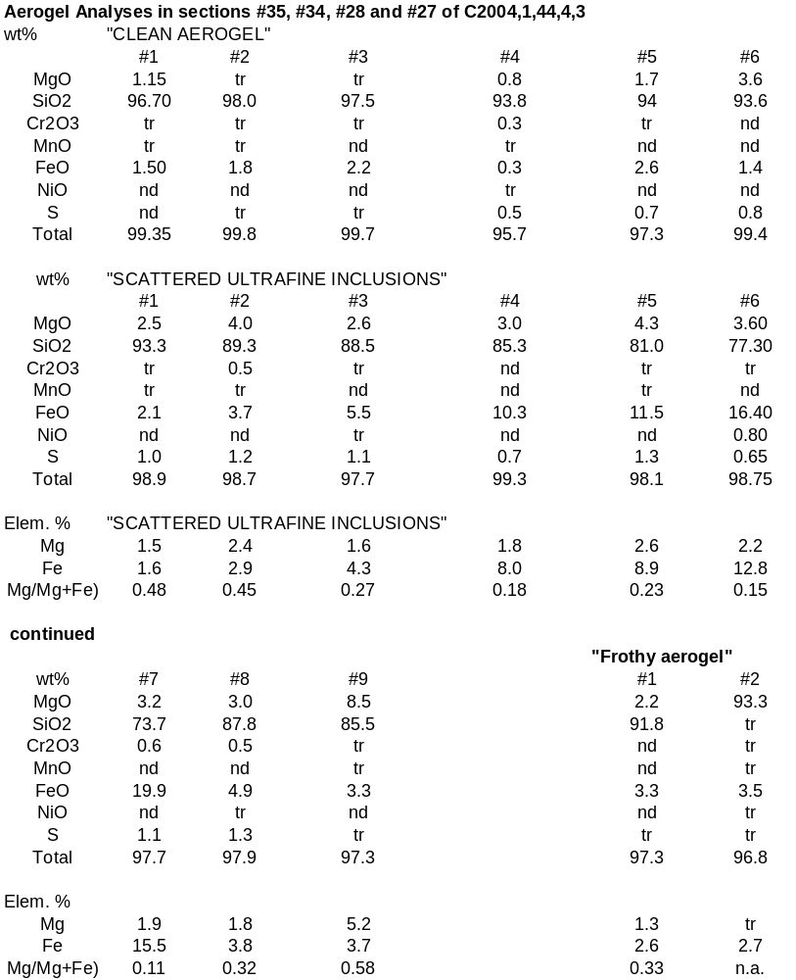
Frothy aerogel (Table 6): Along the very perimeter of some of the sections there are patches characterized by a very high-density agglomeration of ring structures strongly resembling fullerenes. I haven’t noticed this type material in the sections I have reported on so far. This material gives a strong silica signature (Table 6) but contains traces of chlorine (no Na) and carbon. Based on the presence of chlorine I am tempted to conclude this material is a carbon-based embedding medium or perhaps even a carbon thin film support. I requested additional information of the sample preparation and handling procedures from the curator that was promptly forthcoming (see below). I am reasonably sure that the material contains plenty large fullerenes but these carbons have to be treated as an experimental artifact.

From Keiko’s email: Hi Frans,

We buy 100 angstrom thick amorphous C coated Cu grids from LADD Research company. The amorphous C substrates, not just from them but also from any TEM grid companies occasionally contain carbon nanotube looking materials. You can tell they are from manufacture level because nanotubes are located everywhere on the substrate. I guess we received some unfortunate batch of fullerene-containing amorphous C grids and ended up in Frans hands. I cannot tell if they are there in optical microscopes during microtoming unfortunately. Also the sample C2004, 1, 44, 4, 3 is treated/washed severely in acetone and glycolphthalate for synchrotron analysis.

INTERPRETATION: Petrographic textures are not very helpful in establishing process-indicative relationships but I feel confident that the Fe-silicide spheres are the reaction product between iron from comet material and aerogel. If so, the Fe-Si phase diagram would suggest peak-heating temperatures at least on the order of 1200-1400 ºC. The amorphous zone betwen forsterite and aerogel does not represent an “inert compressed aerogel”. It suggests chemical exchange between the comet dust and the aerogel capture medium. The process is unclear: it could be a melt zone or due to solid-state diffusion at very high chemical diffusion rates.

Albuquerque, June 29, 2006

