C2044,0,36
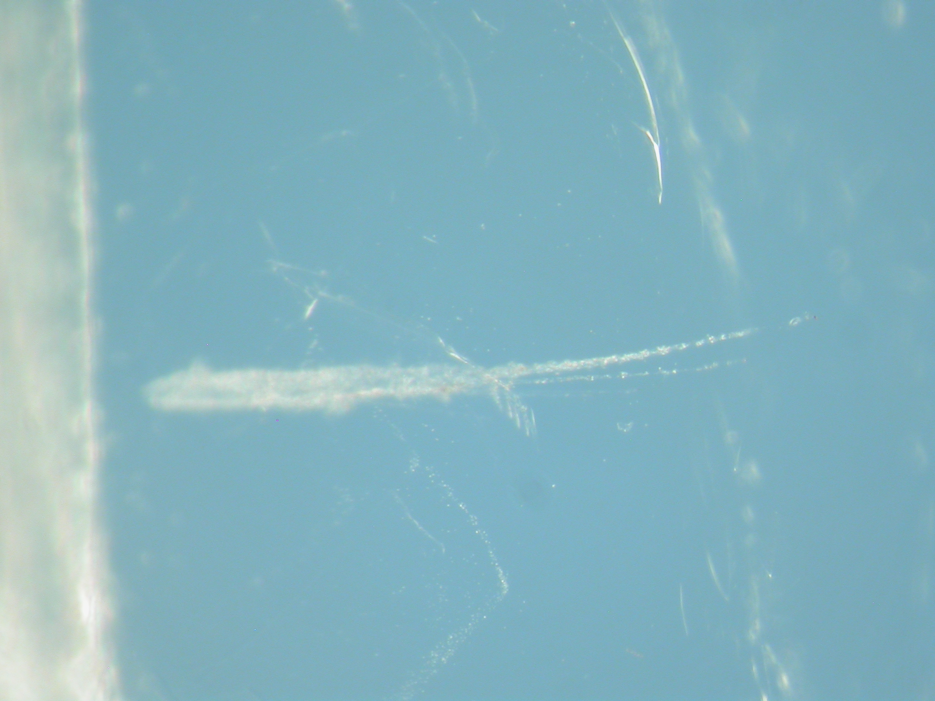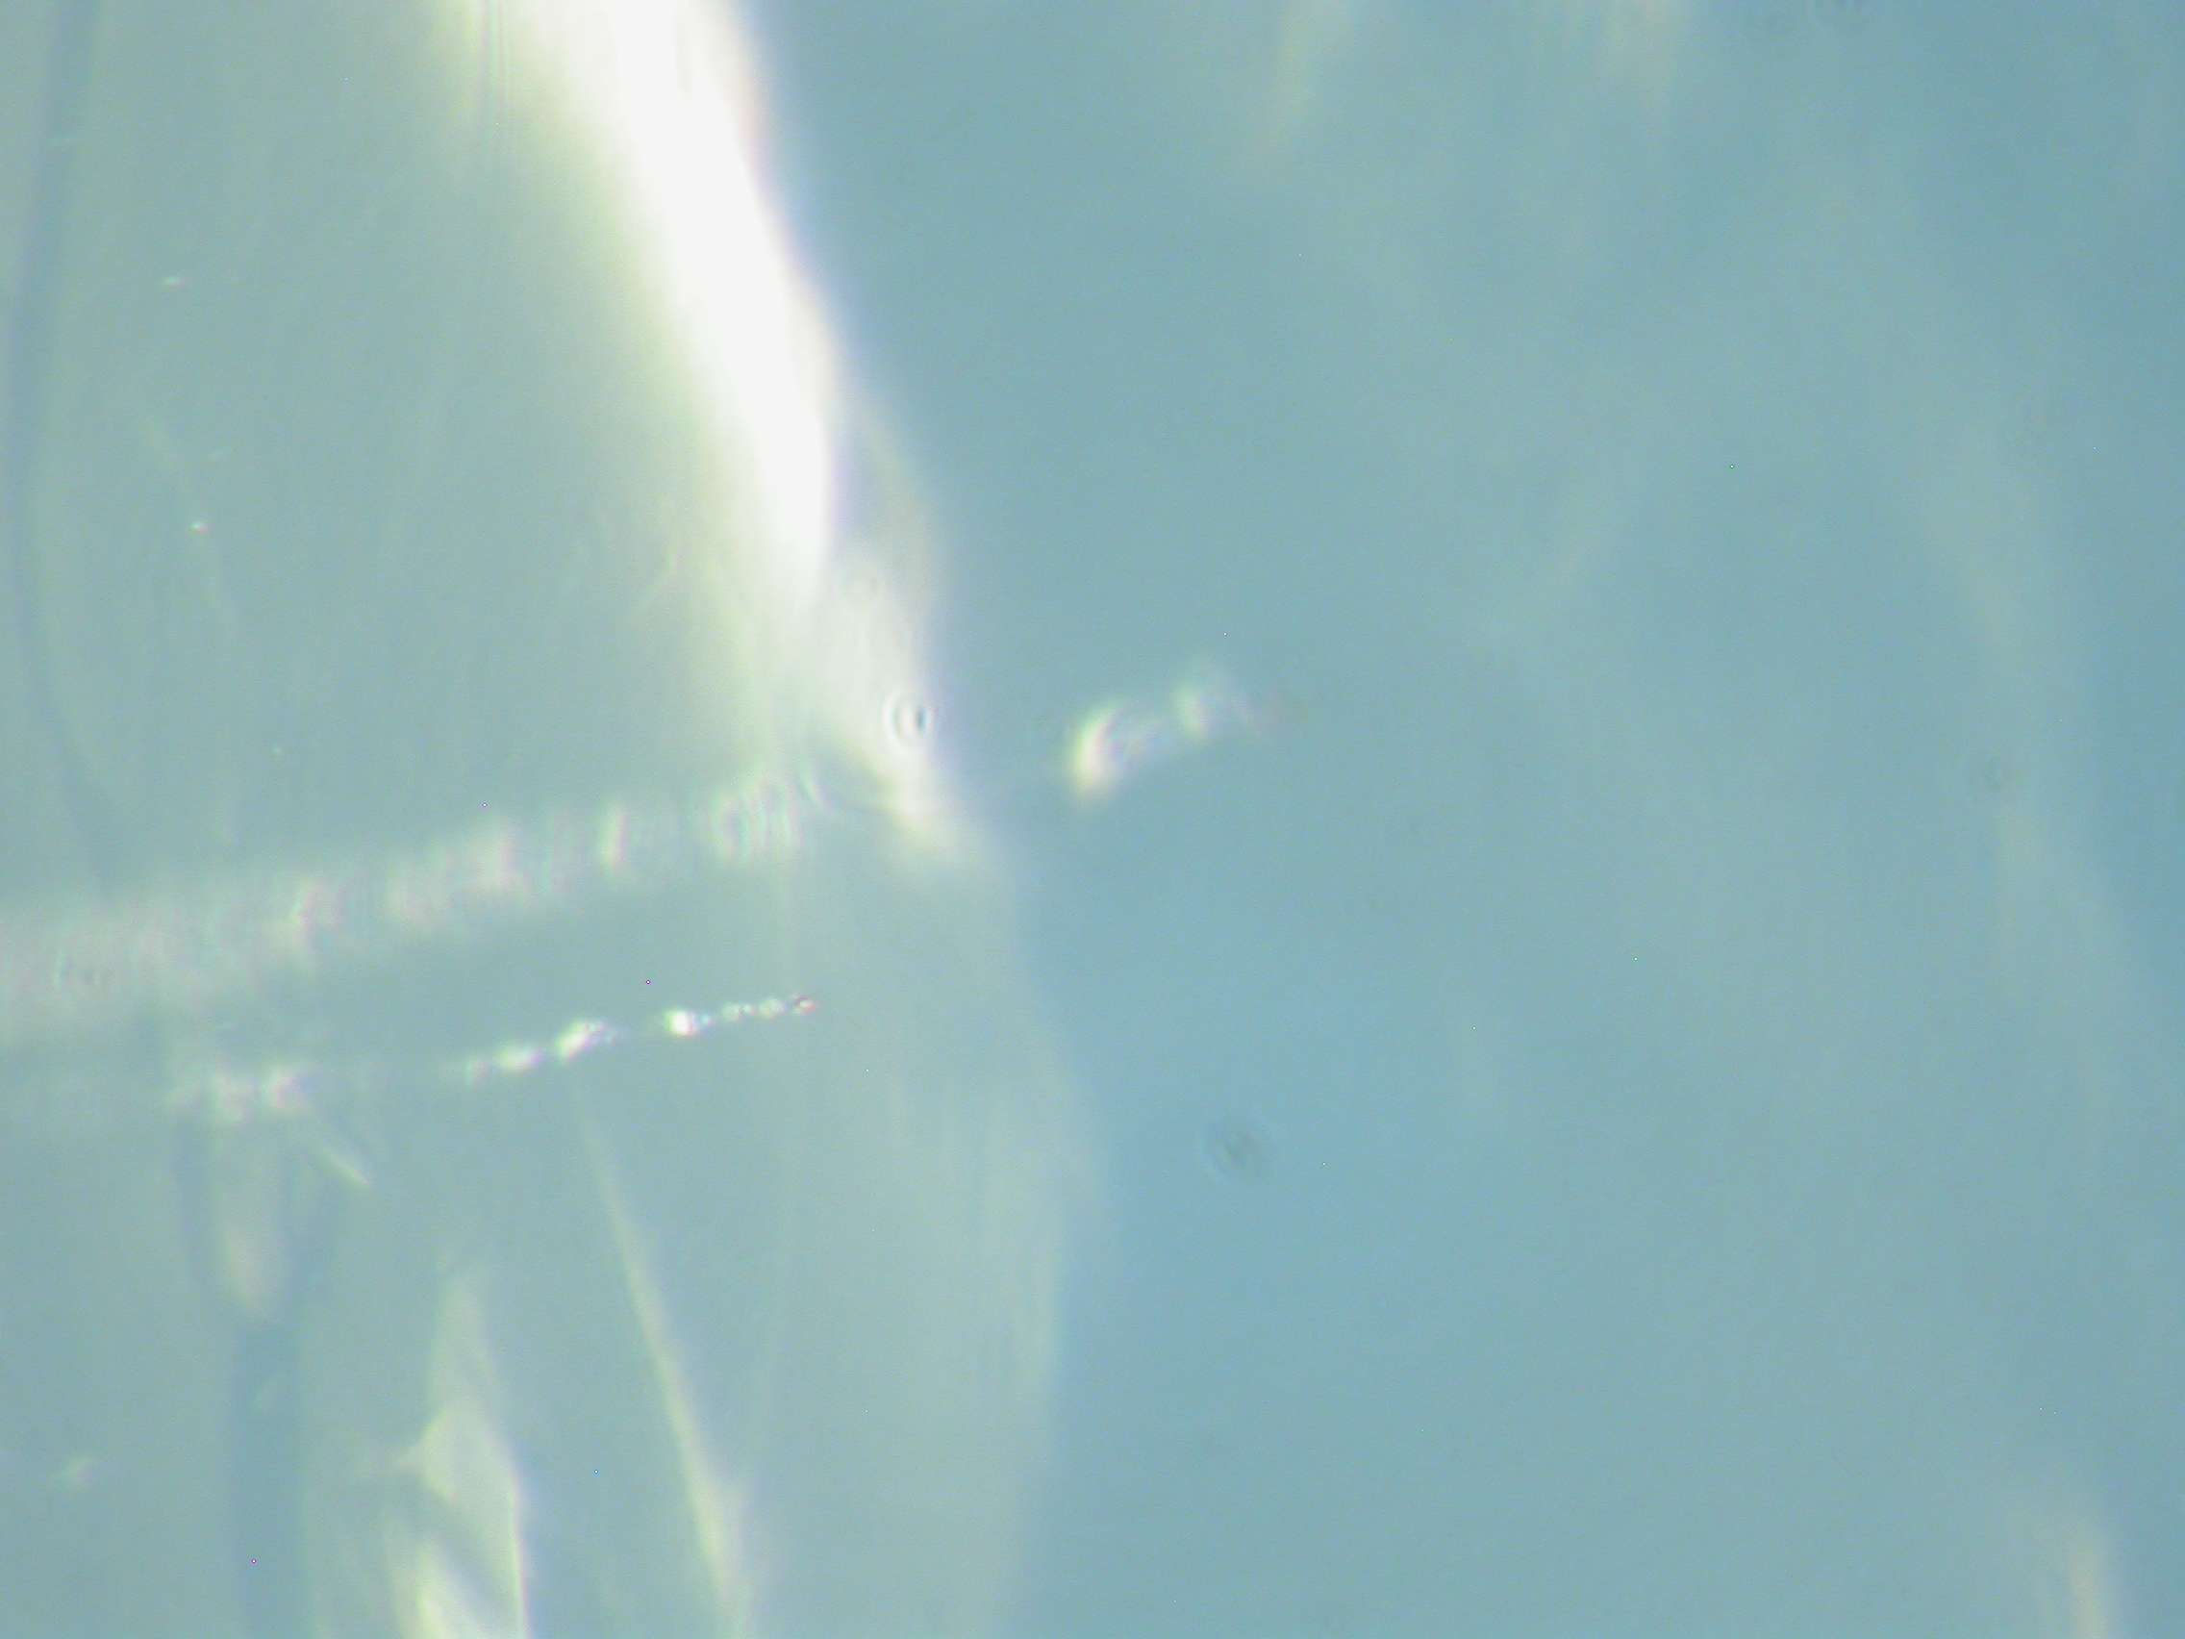

Aliases: Tile 44, track 2
Aegina

Track Characteristics

Type: track on side of tile
Length: ~xxx μm
Deepest particle diameter < x μm

Track History:
Terminal particle extracted and ultramicrotomed 2/06

Images

Aerogel Cell:

Aerogel Keystone:

Track and Grains:

Microtomed samples:

Results

Terminal particle
Min/pet:

Bulk Chemistry:

Organics:

Isotopes:

Data Files:

Allocation History:

To whom were these allocated?

