C2044,0,37

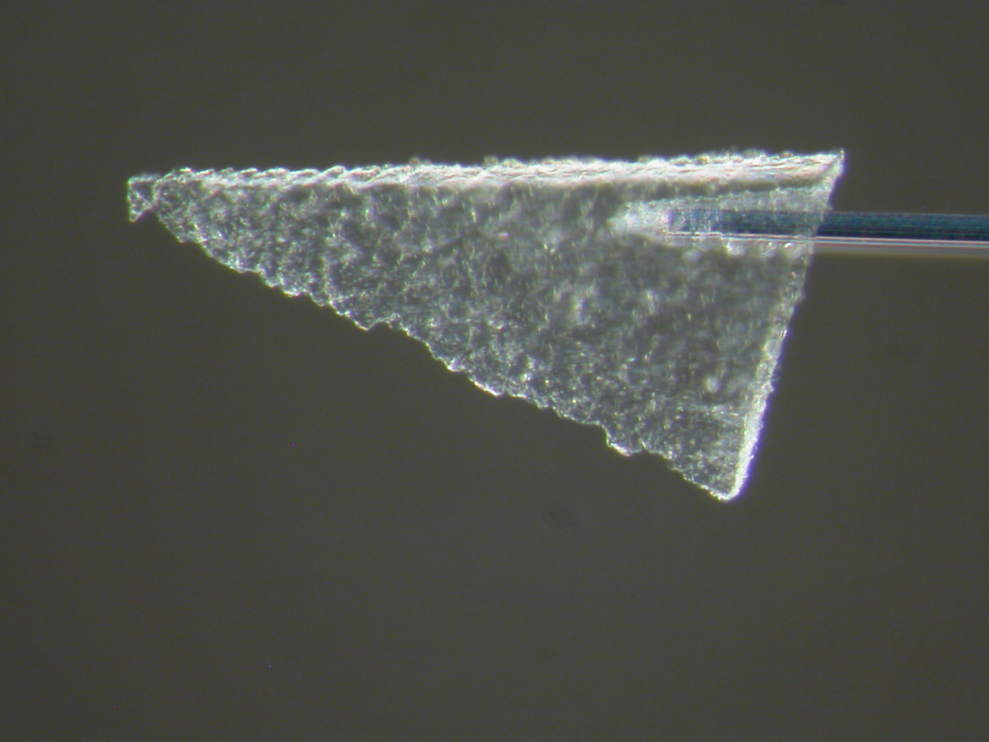

Images

Aerogel Cell: hyperlink here

Aerogel Keystone: hyperlink here

Track and Grains:

Microtomed samples:

Aliases: Tile 44, track 3
Angistri
26feb06

Track Characteristics

Type: small track
Length: 250 μm
Deepest particle diameter < x μm

Track History:
Keystone produced by Snead and Westphal 26feb06
26feb06/sideview.pdf
26feb06/topview.pdf

Allocation History:
Sent to Brenker at Frankfurt 28feb06

C2115,23,21 keystone.

Results

Terminal particle
Min/pet:

Bulk Chemistry:

Organics:

Isotopes:

Data Files: Brenker: Data requested, no response

