C2044,0,41

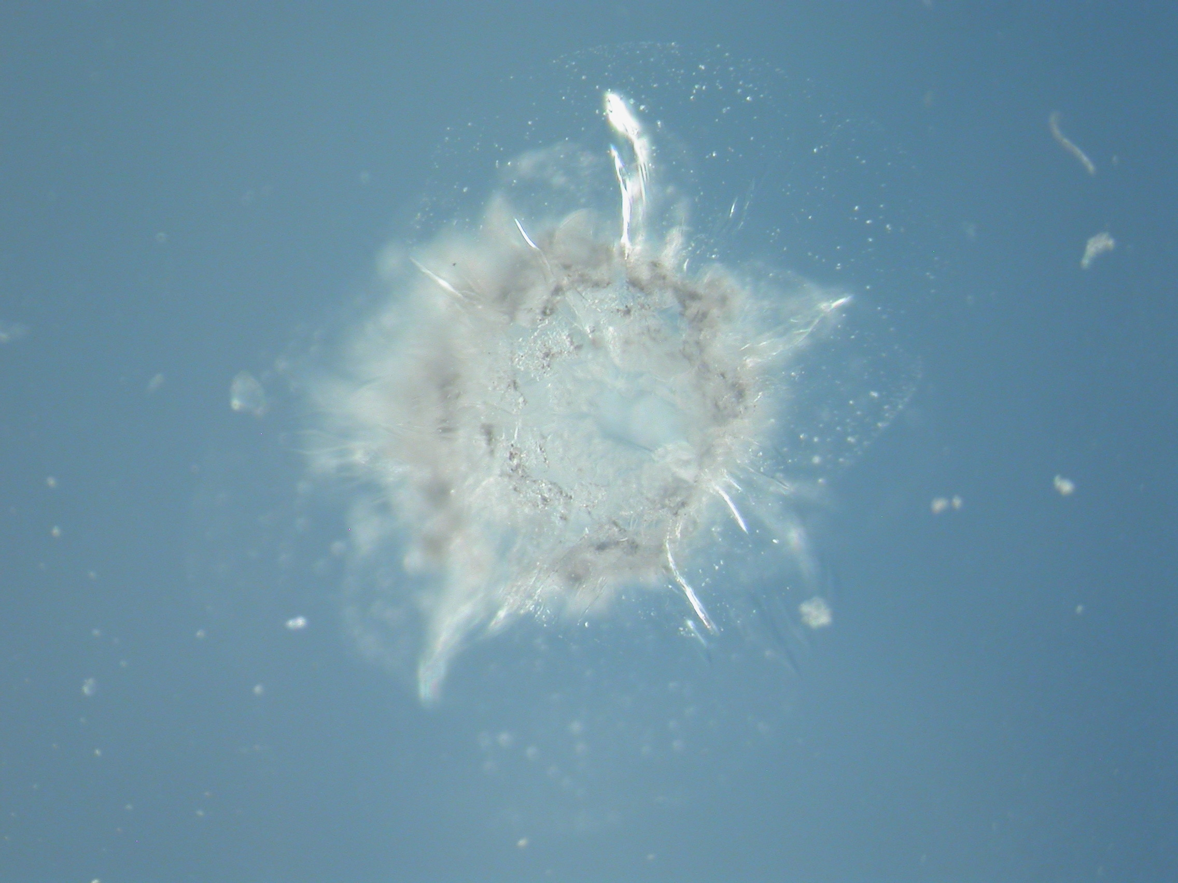
Images

Aerogel Cell: hyperlink here

Aerogel Keystone: hyperlink here

Track and Grains:

Microtomed samples:

Aliases: Tile 44, track 7
Thera

Track Characteristics

Type: large track
Length: ~xxx μm
Deepest particle diameter < x μm

Track History:
Keystone attempted by Snead and Westphal
Keystone failed because of extensive cracking

Fragments of wall saved
Particles extracted

Allocation History:

Westphal: One small fragment analyzed at ALS

Who else has fragments from the wall?

C2115,23,21 keystone.

Results

Terminal particle
Min/pet:

Bulk Chemistry:

Organics:

Isotopes:

Data Files: Westphal ALSrunnotes.ppt

