Sample Information Sheet

Sample ID: C2037N
Sample type (select one):
(6) foil

Type of analysis performed: SEM search for impact craters; C-, N-, O-, and S-isotopic compositions and EDX in small craters

State of sample pre-analysis: good
State of sample post-analysis (select one): partly consumed (202 crater residues)
Minerals or other phases identified:

- a. elemental composition (for species at >0.5wt%):
19 crater residues analyzed, see Table below
b. isotopic composition:
O: 183 crater residues analyzed;
δ¹⁷O = -108 ± 82 ... 202 ± 135 ‰
δ¹⁸O = -52 ± 52 ... 111 ± 38 ‰
1 crater residue with presolar O-isotopic signature identified:
δ¹⁷O = 128 ± 67 ‰
δ¹⁸O = 167 ± 41 ‰
(normalized to contamination on Al foil);
C, N: 6 crater residues analyzed;
δ¹⁵N = 18 ± 83 … 266 ± 47 ‰
δ¹³C = -36 ± 13 … 17 ± 15 ‰
(normalized to foil contamination);
S: 13 crater residues analyzed;
δ³³S = -78 ± 26 … 29 ± 13 ‰
δ³⁴S = -37 ± 6 … 20 ± 3 ‰
δ³⁶S = -177 ± 77 … 61 ± 61 ‰
c. size: 0.1-4.4 μm (659 craters identified in 9.5 mm²)
d. mineral associations: see Table below

Contaminant phases identified (including melted aerogel):

Additional Notes: (paste sample image and /or EDS spectrum in JPEG format here if available)
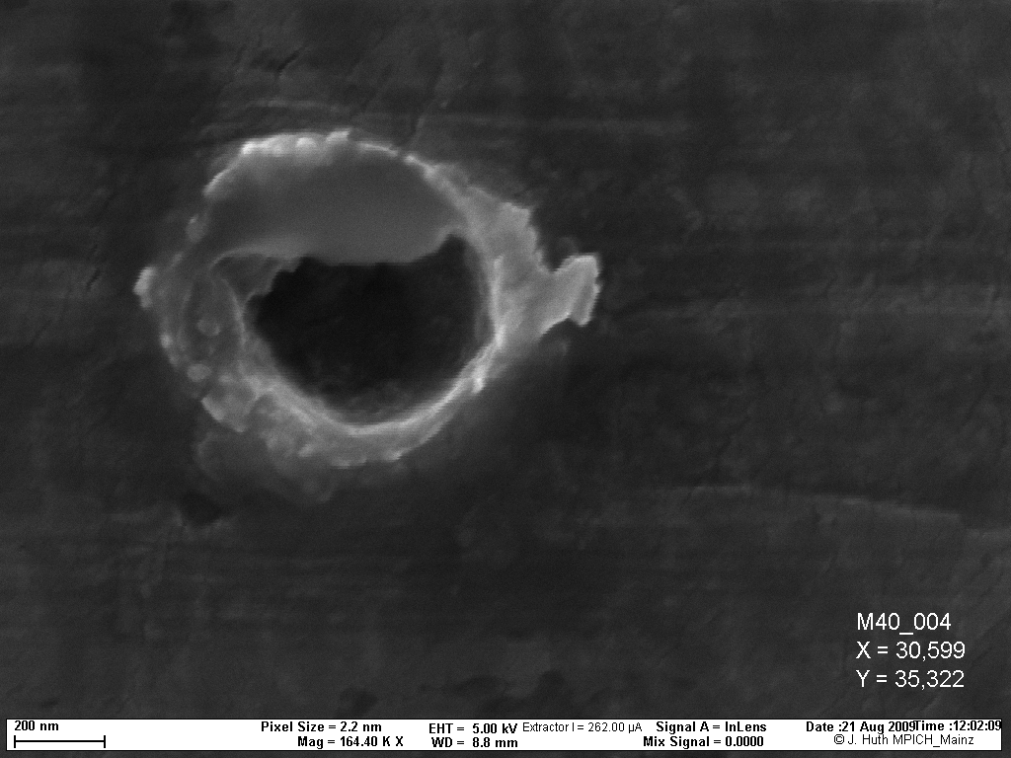
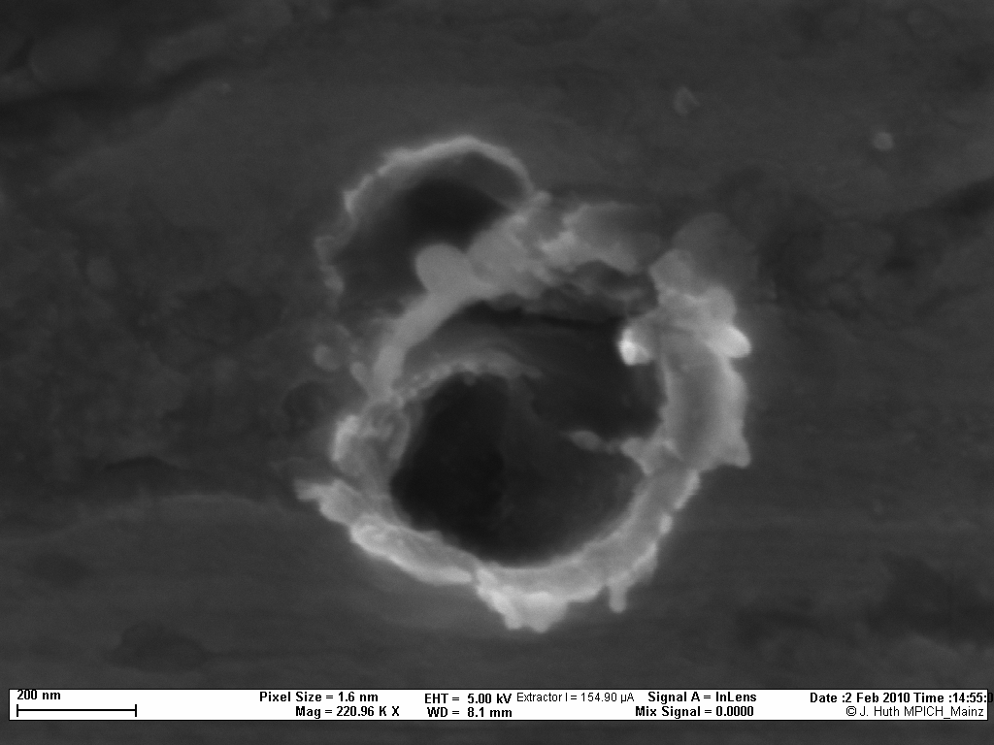
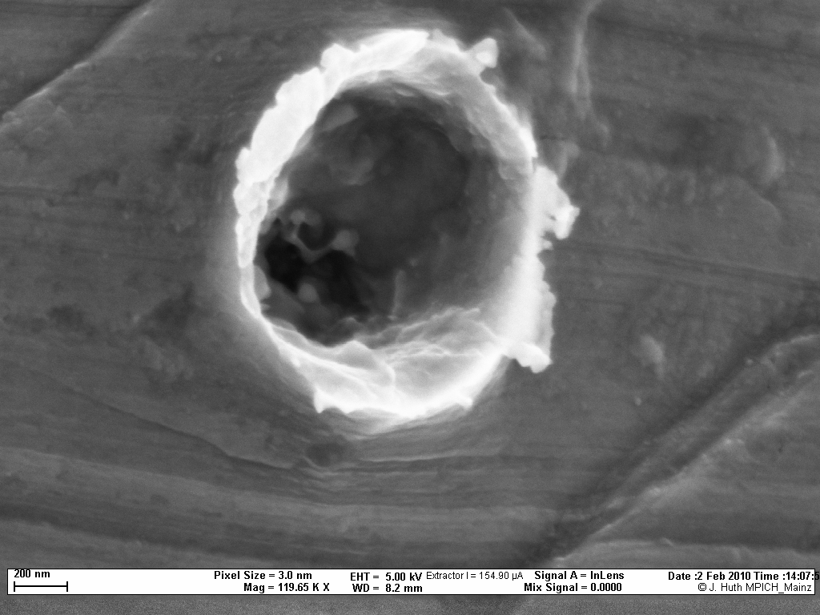
Crater with presolar impact residue

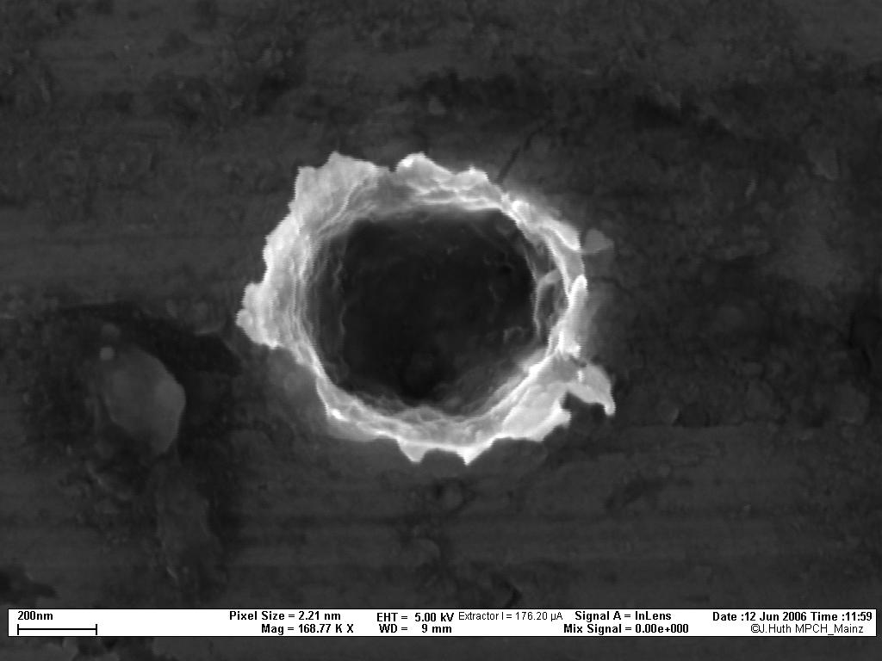
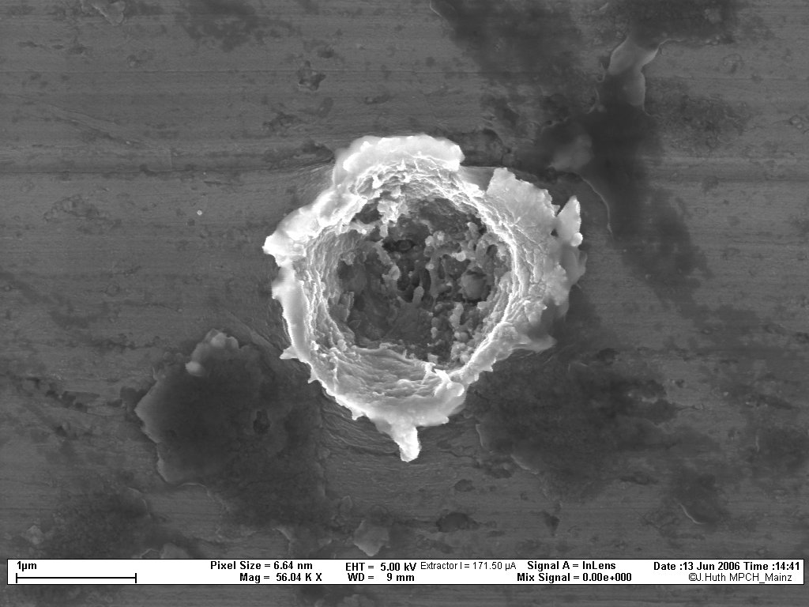

SEM pictures of selected impact craters, including the crater with presolar impact residue (upper row, left).

Crater No. | Mg [at%] | Si  [at%] | S  [at%] | Fe  [at%] | Ni  [at%] | O  [at%] | others | Mineralogy, qualitatively
4 | 16.1 | 15.2 | 0.0 | 6.4 | 0.0 | 62.3 |  | Silicate
7 | 18.8 | 14.0 | 0.0 | 6.1 | 0.0 | 61.1 |  | Silicate
8 | 17.9 | 19.5 | 0.0 | 2.4 | 0.0 | 60.2 |  | Silicate
12 | 0.0 | 0.0 | 50.8 | 49.2 | 0.0 | 0.0 |  | FeS
14 | 11.5 | 23.9 | 0.0 | 0.0 | 0.0 | 64.6 | Ca | Silicate
 | 10.6 | 23.3 | 0.0 | 0.7 | 0.0 | 65.4 | Ca
 | 10.6 | 21.9 | 0.0 | 0.0 | 0.0 | 67.5 | Ca
18 | 0.0 | 0.0 | 58.9 | 31.1 | 9.9 | 0.0 |  | (Fe-Ni)S
20 | 14.7 | 18.9 | 4.1 | 4.2 | 0.0 | 62.2 |  | Silicate + FeS
25 | 0.0 | 0.0 | 58.5 | 41.5 | 0.0 | 0.0 |  | FeS
27 | 19.1 | 20.0 | 0.0 | 1.5 | 0.0 | 59.4 |  | Silicate
 | 14.9 | 23.1 | 0.0 | 1.0 | 0.0 | 61.0
 | 17.4 | 21.2 | 0.0 | 1.3 | 0.0 | 60.0
 | 20.5 | 16.5 | 0.0 | 3.5 | 0.0 | 59.5
32 | 14.8 | 15.8 | 5.4 | 6.5 | 0.0 | 63.0 |  | Silicate + FeS
35 | 10.6 | 5.9 | 12.0 | 15.6 | 0.0 | 67.9 |  | Silicate + FeS
 | 11.0 | 15.3 | 8.9 | 8.5 | 0.0 | 65.2
 | 15.2 | 18.7 | 2.8 | 4.1 | 0.0 | 61.9
37 | 15.7 | 21.6 | 2.7 | 1.8 | 0.0 | 60.9 |  | Silicate
 | 16.7 | 21.1 | 1.6 | 1.7 | 0.0 | 60.5
 | 16.5 | 19.6 | 1.4 | 2.9 | 0.0 | 61.0
39 | 12.7 | 9.4 | 12.8 | 12.1 | 0.0 | 65.8 |  | Silicate + FeS
 | 10.5 | 7.7 | 13.7 | 14.3 | 4.1 | 67.5
 | 10.7 | 9.1 | 13.4 | 13.2 | 8.6 | 67.0
 | 13.6 | 12.4 | 18.0 | 9.5 | 0.0 | 64.5
 | 13.6 | 15.9 | 10.8 | 6.9 | 0.0 | 63.6
46 | 18.7 | 14.1 | 6.5 | 6.1 | 0.0 | 61.2 |  | Silicate + FeS
 | 20.4 | 12.9 | 4.8 | 6.2 | 0.0 | 60.5
 | 18.6 | 13.4 | 4.3 | 6.7 | 0.0 | 61.4
47 | 14.8 | 12.7 | 10.4 | 8.8 | 0.0 | 63.7 |  | Silicate + FeS
48 | 17.5 | 17.3 | 1.9 | 4.2 | 0.0 | 61.0 |  | Silicate
 | 13.1 | 18.3 | 2.7 | 5.3 | 0.0 | 63.3
49 | 19.4 | 21.9 | 0.0 | 0.0 | 0.0 | 58.7 |  | Silicate
50 | 16.3 | 10.7 | 9.6 | 9.6 | 0.0 | 63.4 |  | Silicate + FeS
 | 17.9 | 14.7 | 1.6 | 3.0 | 0.0 | 64.3
56 | 23.0 | 19.0 | 0.0 | 0.6 | 0.0 | 57.4 |  | Silicate + FeS
 | 17.4 | 21.4 | 0.0 | 1.1 | 0.0 | 60.2 | Na
 | 15.5 | 12.3 | 2.8 | 8.5 | 0.0 | 63.7 | Na
 | 16.8 | 14.5 | 2.4 | 6.6 | 0.0 | 62.1
 | 15.2 | 15.2 | 3.5 | 6.8 | 0.0 | 62.9
 | 6.6 | 29.2 | 0.0 | 0.0 | 0.0 | 64.2

