C2009,xx,xx

Images

Aerogel Cell: hyperlink here

Aerogel Keystone: hyperlink here

Track and Grains:

Microtomed samples:

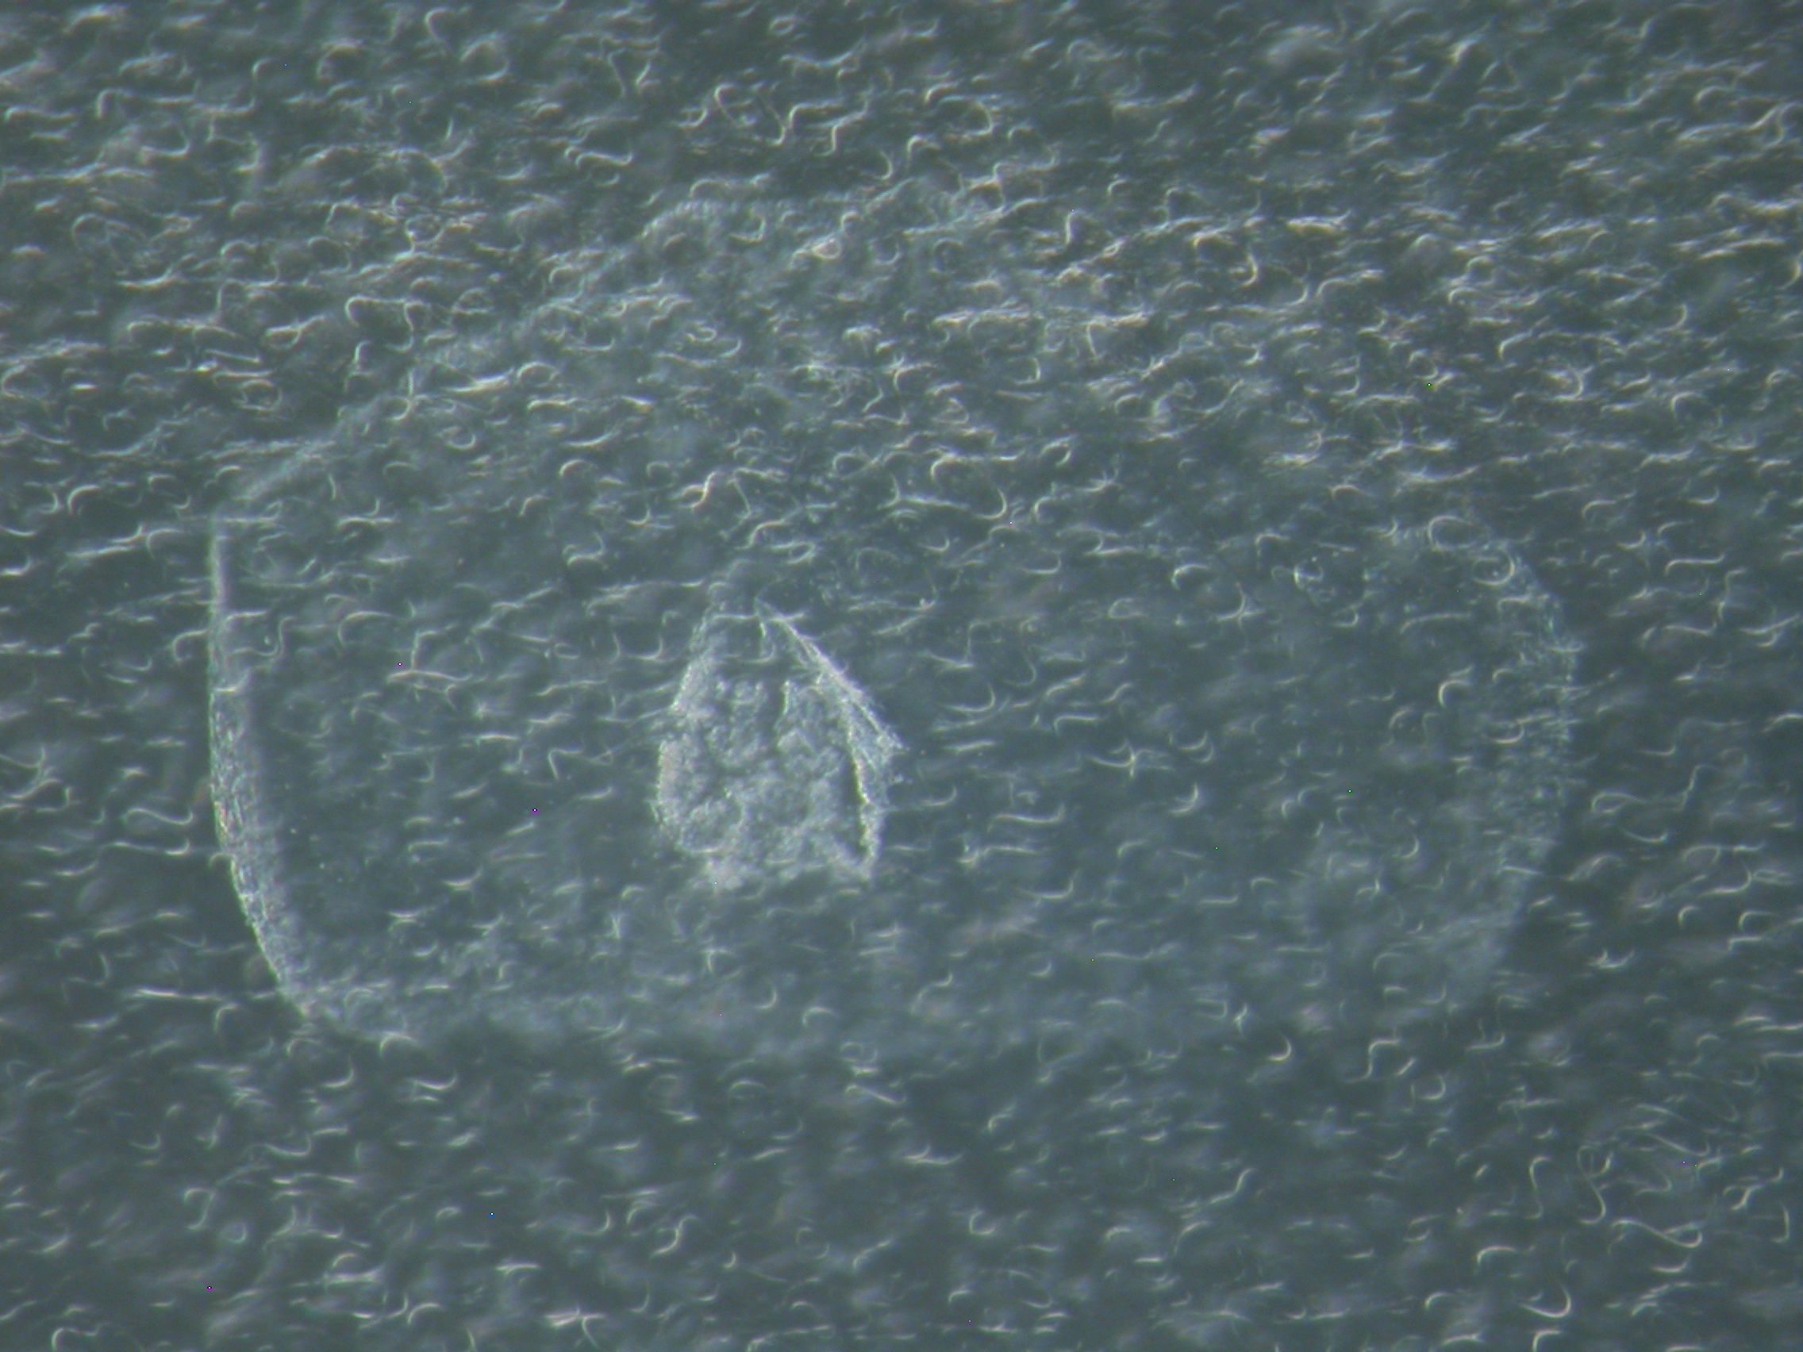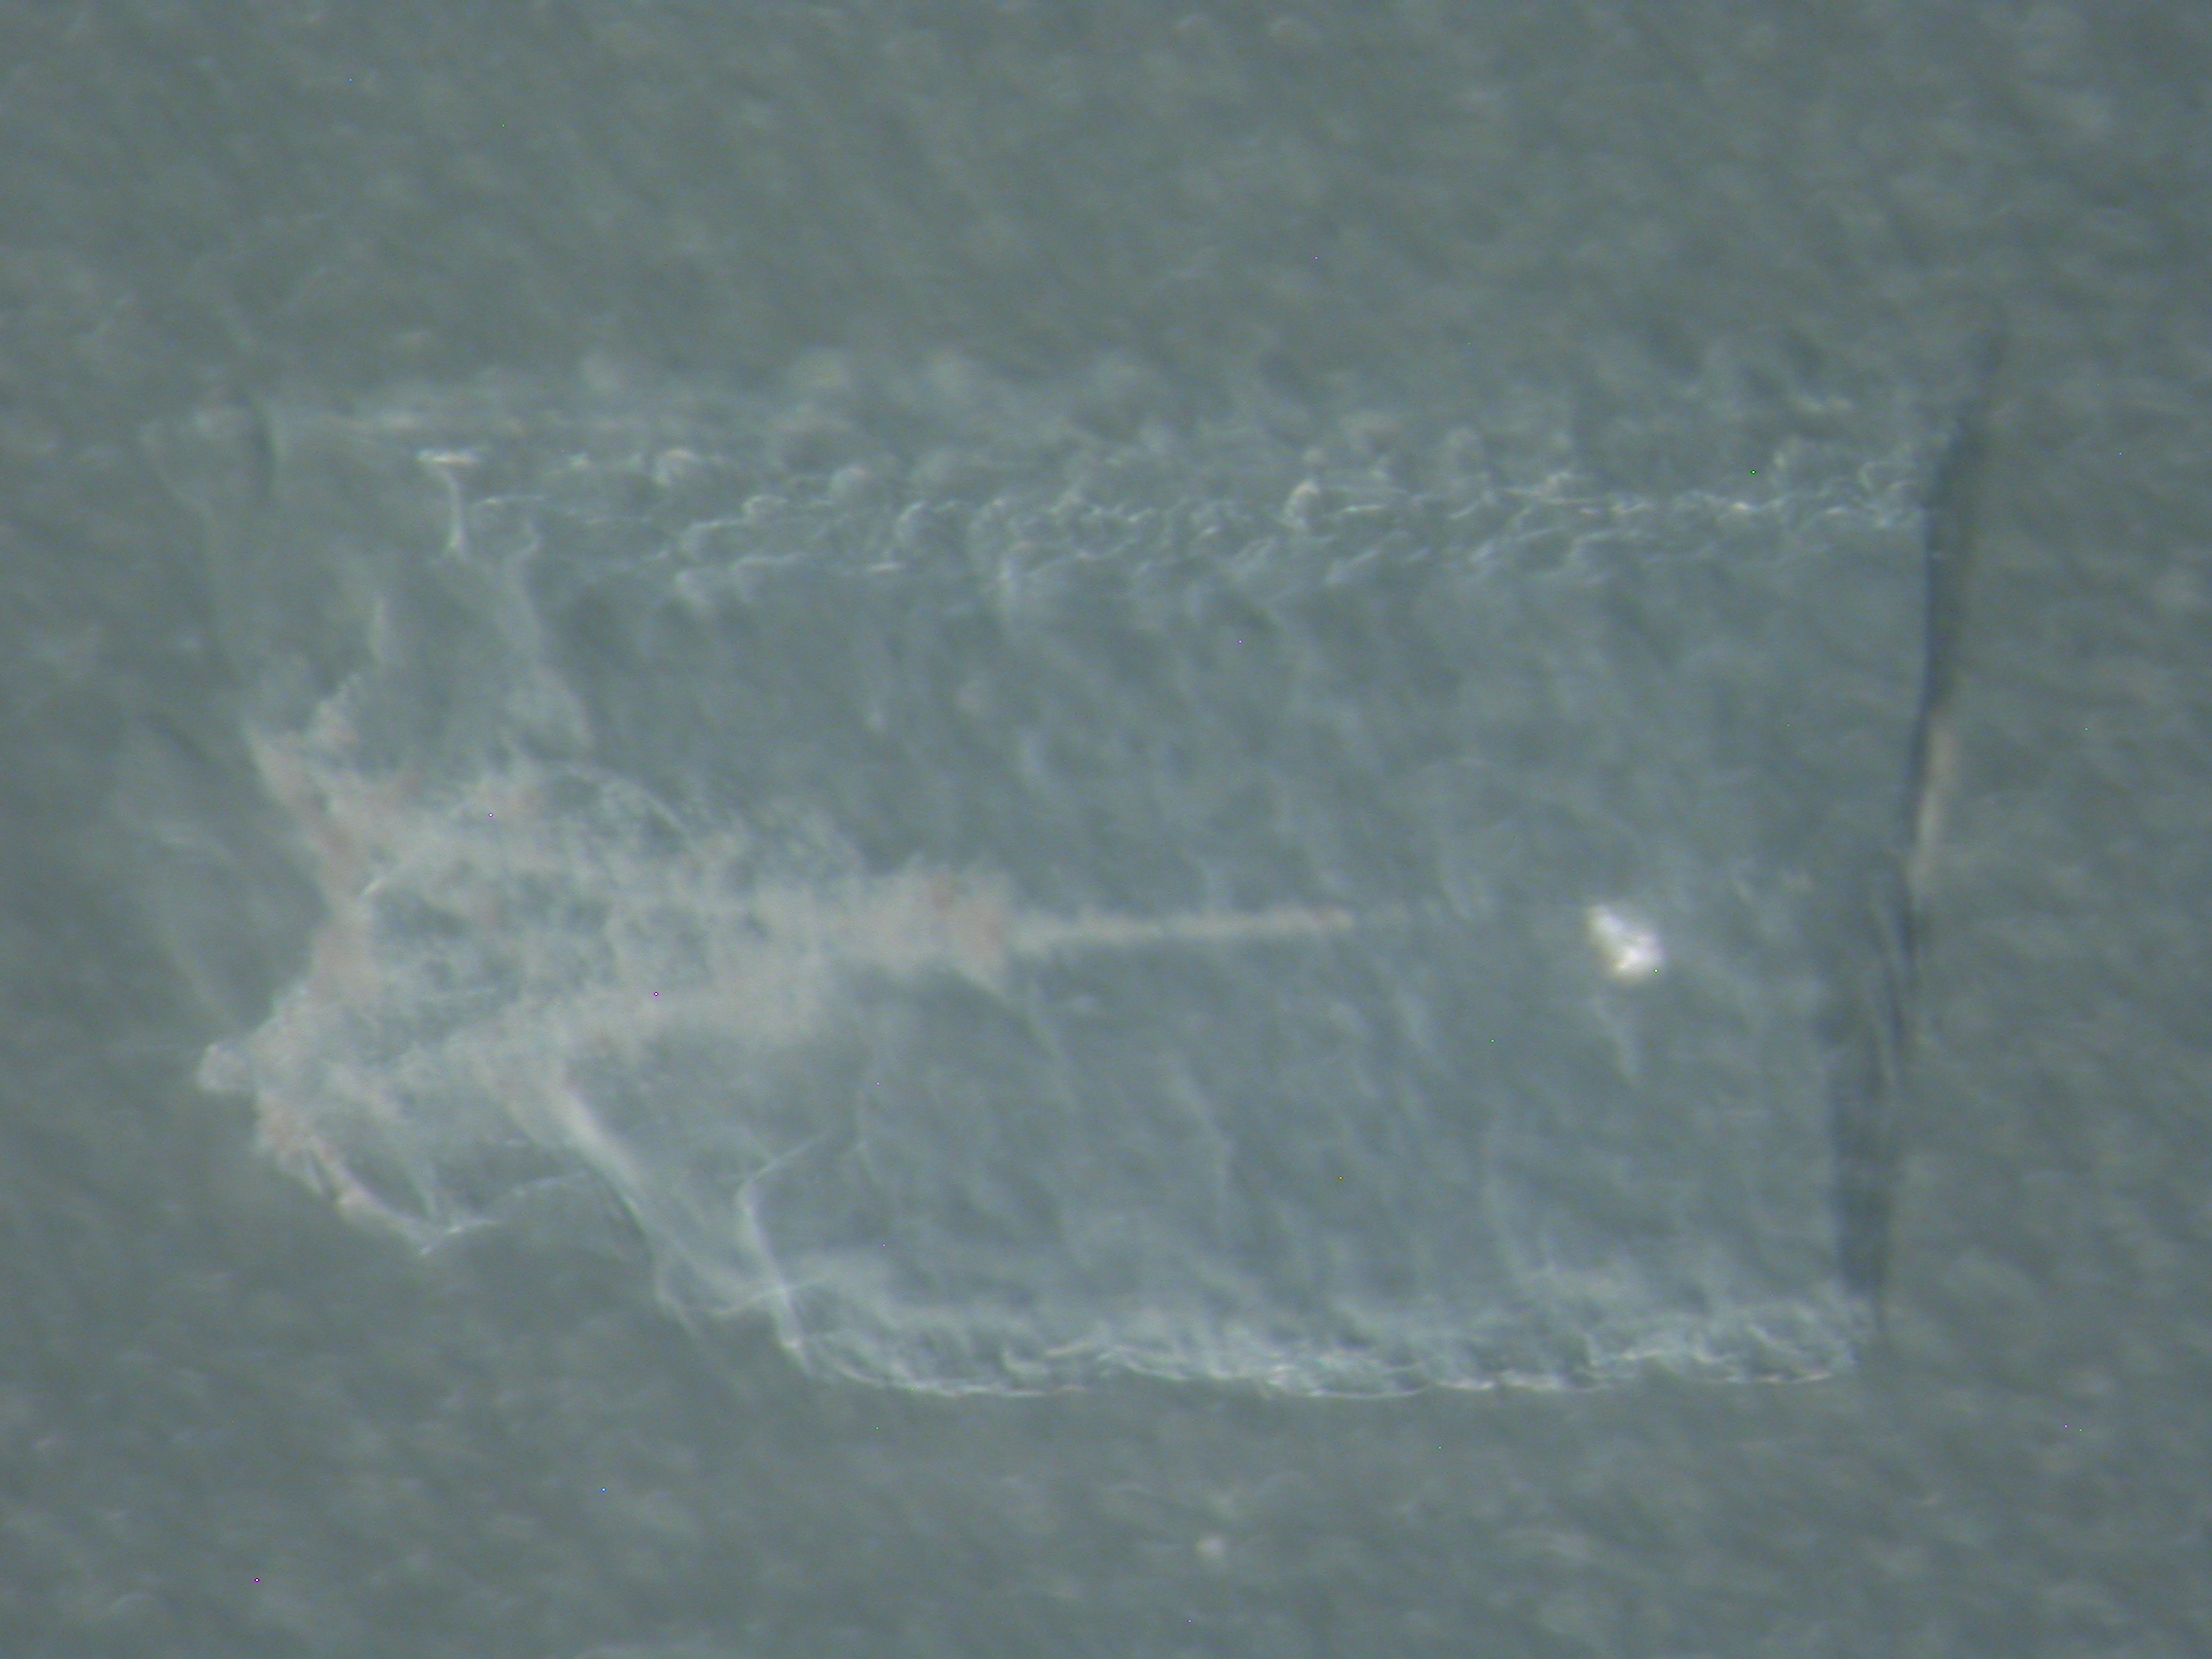

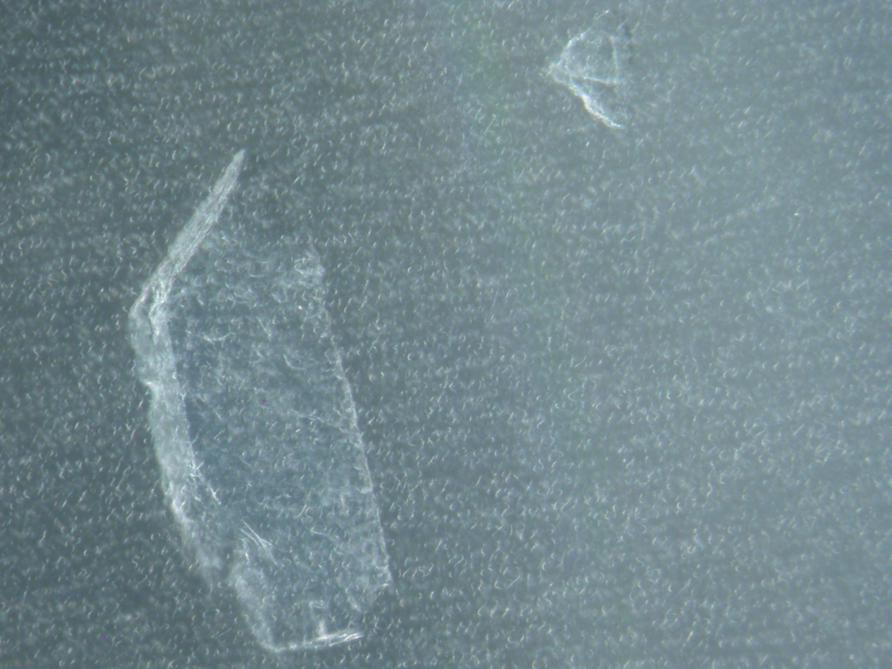

Aliases: xx

Track Characteristics

Type: large track from side of tile 9
Length: ~xx μm
Deepest particle diameter < xx μm

Track History:
Prepared by Gainsforth at Berkeley
May 2006

Allocation History:

Sent to Steve Sutton at Argonne National Laboratory (U Chicago) on 9 June 2006

Results

Terminal particle
Bulk Chemistry:

Organics:

Isotopes:

Data Files:
Brownlee: no yet

C2115,23,21 keystone.

